# Friends Birthday Tracker – User Manual

This application was made to help all users keep track of their friend’s birthdays throughout the year. You are also able to enter information about their likes and dislikes which will help when it comes to selecting a present.

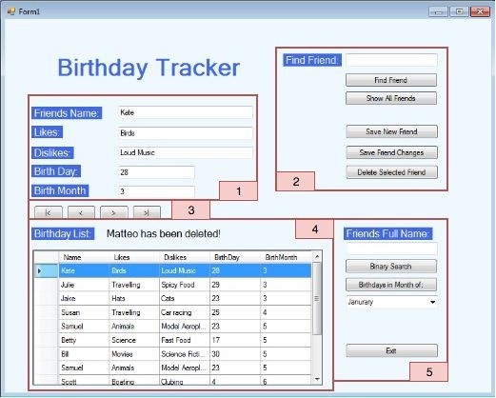

(Image 1.0 – User Interface)

There is only one user interface available which can be broken up into 5 sections:

* Image 1.0 – Section 1: This section shows all relevant information related to the currently selected friend. These fields are:
  1. Friend’s Name
  2. Likes
  3. Dislikes
  4. Birth Day – The day of which they were born
  5. Birth Month – The month of which they were born
* Image 1.0 – Section 2: This section contains the functions needed to search for, add and edit friends. These functions are:
  1. Find Friend –You can search for a friend by entering a partial name into the text box above the button. If a partial name is entered, any matches will return a new list of friends where their name contains that searched value. If only a single person is found, they will be highlighted in the list and the fields in section 1 will be populated.
  2. Show All Friends – This can be used to show all the friends you have saved if the list in Section 4 is not showing them all.
  3. Save New Friend – Entering a new friends details into the text fields within Section 1, you can then click this button to save the friend to the database. When adding a new friend, you must ensure that their name will be unique within the list. If you have two people with the same name, it is recommended that you use the initial of their last name to separate them e.g. Katie S. If an invalid date is entered you well get a warning message to correct this.
  4. Save Friend Changes – After selecting a friend in the list in Section 4 and populating the text fields in Section 1, you can alter any fields and then select this button to save the changes.
  5. Delete Selected Friend – If you have a friend selected in the list in Section 4, you can click this button to remove the friend from the database. **Be careful, you are not able to recover your friend information after they have been deleted.**
* Image 1.0 – Section 3: These buttons move through the records in the list. The functions will be listed from left to right.
  1. First Record – Selects the first row at the top of the list.
  2. Previous Record – Selects the previous row above the currently selected row.
  3. Next Record – Selects the next row below the currently selected row.
  4. Last Record – Select the very last record at the bottom of the list.
* Image 1.0 – Section 4: This is the interactive list that when you click on a row, the fields in Section 1 will automatically populate with the information related to that friend. There is also a message line above the list that will relay information that may be important for you to know. None of the details within the list can be edited directly in the list.
* Image 1.0 – Section 5: Alternative Searches.
  1. Binary Search – This is an alternate search option where you enter the full name of your friend into the text field above and click the ‘Binary Search’ button. The result will be displayed in the list view.
  2. Birthdays in Month of: You can view all the birthdays relevant to a specific month. First you need to select the month in the dropdown and then select the ‘Birthday in Month of’ button. This will then display all the birthdays for the selected month in the list view.
  3. Exit – This will close the application.